**Probability Project**

**Grades 9-12**

**Summer 2017 - MATH 6600**

**Tom Demars, Amanda Procopio, & Meghan Brautigam**

**Executive Summary**

Probability is an important piece of the high school curriculum that connects to discrete mathematics and critical thinking skills. With the skills to analysis data that they have either been given or collected. The skills gained from probability can be used in their future careers and as they continue to explore mathematics at the high school and college level.

The following units include activities that students will work on displaying a sample space through area models, trees, and tables. These activities allow students to explore experimental and theoretical probability, along with fairness of probability. Comparing data through Venn diagrams and critical thinking questions. Students will also work with counting using combinations and permutations. The students explore expected value through experiments and their own data collection.

The following mini units can be used to in sequence or as individual lessons to put into any curriculum. These units are not meant to be taught consecutively; they may work as activities before or after your units they follow in the curriculum you teach from, or they may be used as fun activities at any time.  All the following lessons and activities have the Minnesota State Standards that they meet at the beginning of the lesson. Lessons also include what prior knowledge students should have before they begin the activity to help you place them into your curriculum. All activities are meant to be in small groups or partners.

**Table of Contents**

**Models of Sample Space 2 days**

Day 1 Starburst (creating an area model) Page 4-6

Day 2 Caves (area model/trees/tables) Page 7-8

**Experimental/Theoretical Probability 5 days**

Day 1 Kalvin’s Marshmallows (collecting data and finding probability) Page 9

Day 2 Hey, That’s Not Fair (comparing experiments and theoretical probability) Page 10-12

Day 3 More than 2 events (looking at compound events probabilities) Page 13-14

Day 4 & 5 Abby’s Kennel (working with collected data in tables)

(Venn diagrams and comparing the data, critical thinking questions) Page 15-21

**Counting 3 days**

Day 1 Lottery (How many possibilities, how would we count them. Could be connected to is it fair and lead into counting.) Page 22-23

Day 2 &3 Clever Counting (counting lock combinations why did you set up the experiment that way you did.)

(path ways, what would be your next steps) Page 24-28

**Expected Value 5 days**

Day 1 Rank by Preference Page 29

Day 2 Candy Math (Expected Value Introduction) Page 30-32

Day 3 Expected Value Page 33

Day 4 Who is the Winner (Expected value examples) Page 34-35

Day 5 Expected Value Carnival Page 36

**Pre/Post Tests** Page 37-

**Day 1 Starburst (area models)**

9.4.3.1 Select and apply counting procedures, such as the multiplication and addition principles and tree diagrams, to determine the size of a sample space (the number of possible outcomes) and to calculate probabilities.

9.4.3.2 Calculate experimental probabilities by performing simulations or experiments involving a probability model and using relative frequencies of outcomes.

Note this lesson could be used as an introduction to area models and how to build one.

**Objectives:** Students will develop a probability area model and use it to find probabilities of events.

**Materials:** Masking tape, dry-erase markers, plastic cups/containers, assorted colored candies or marbles, starburst hand out.

**Launch:** The teacher will hand out the supplies and ask the students to randomly select 3 starbursts to go into the first cup and 4 to go into the second cup. The teacher will have already made a square with either masking tape or just marker on the board to represent the complete sample space. The teacher will than ask the students to work together to complete the sample space by showing all the possible outcomes.

**Explore:** Students will work in small groups to complete their area model and fill in all the sample space. Students will identify and give notation of each of the colors when completing this. Students will identify the total number of possible outcomes and give the results of what their table shows from different probability outcomes both specific outcomes in their table, outcomes that do not exist and probabilities that look at only part of the complete outcome. (possible questions available in hand out) Additional thought questions to extend this lesson also in hand out.

**Share:** Students will share their outcomes and discuss how they created their area model and why they differ from one another (note not all students need to have the same colors in their cups). Q: Does this show all of the possible outcomes and why? Groups will also share with the class how they could insure that they get at least one of a specific color and why they believe that will work. (have them show how the sample space shows that) How would that change the sample space.

**Summarize:** The teacher will review the groups thoughts and make sure students understand that the reason the 3 by 4 area model was used was because there were 3 choices in cup one and 4 choices in cup 2. Connect the area model to a multiplication chart if students are having a hard time seeing how the different outcomes are found. Talk about how the different probabilities can be found by counting within the sample space.

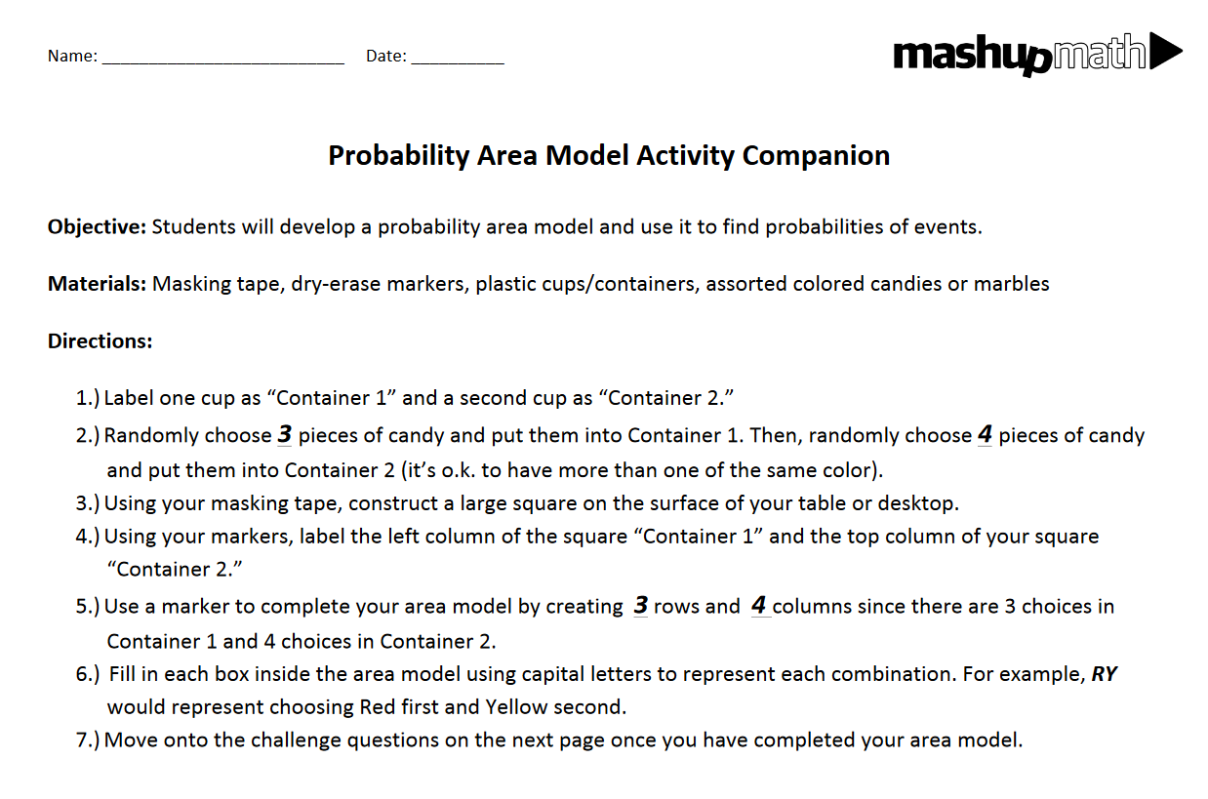

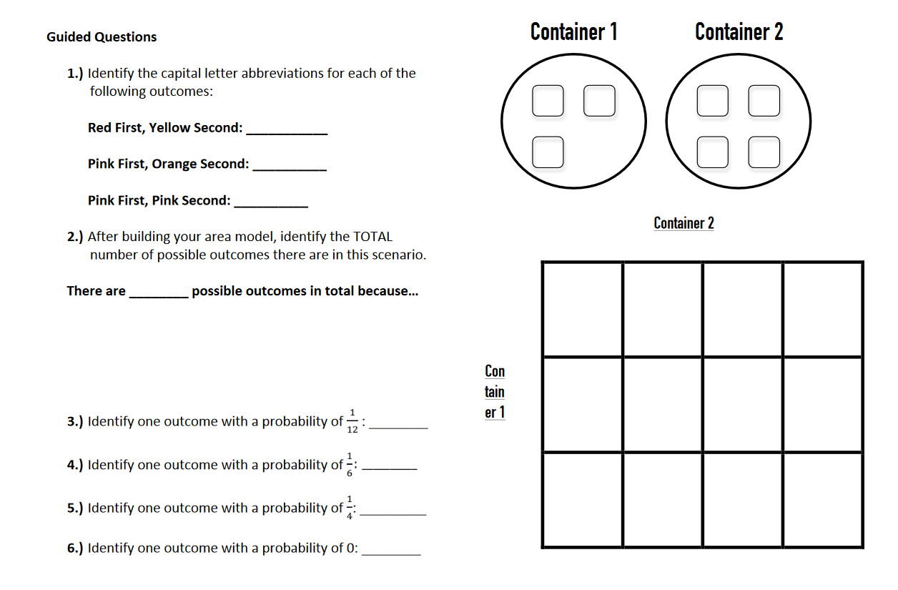

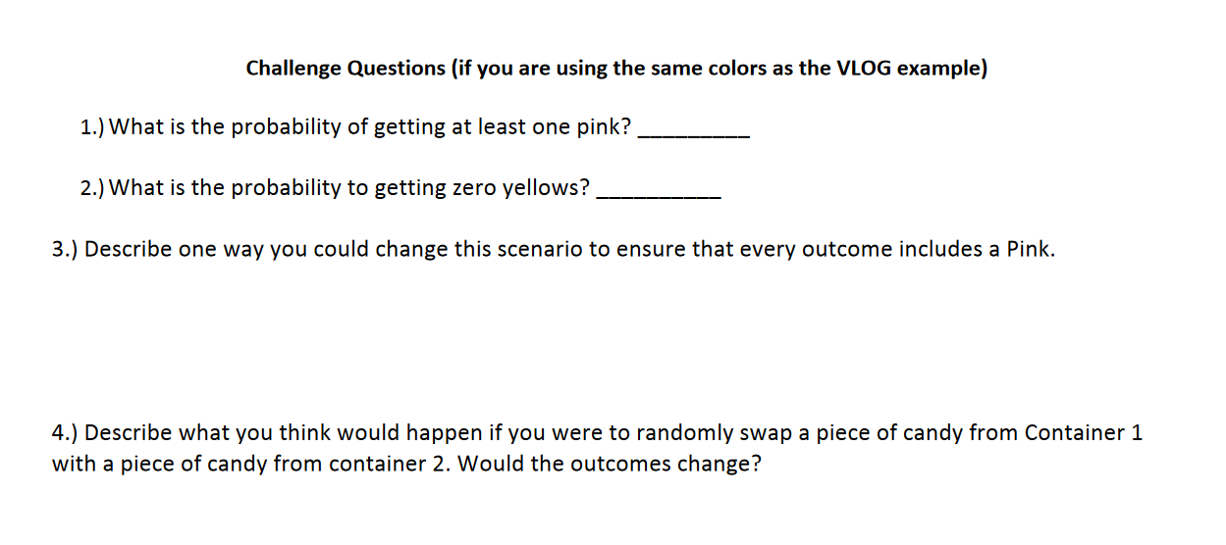

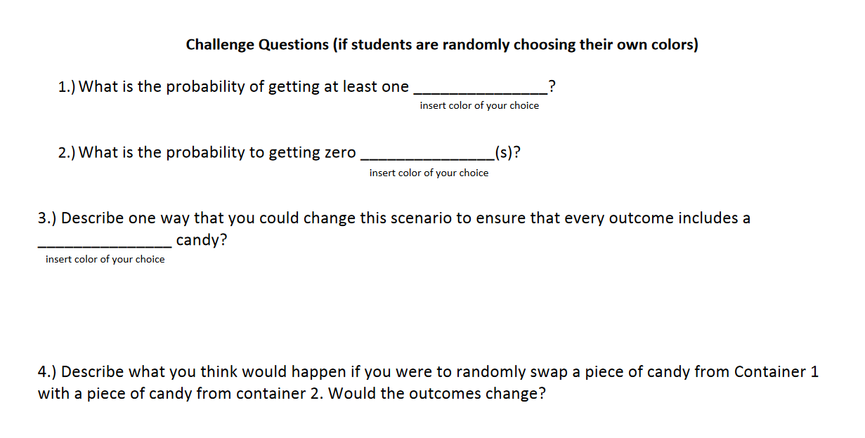

**Day 2 Caves (area model/trees/tables)**

9.4.3.1 Select and apply counting procedures, such as the multiplication and addition principles and tree diagrams, to determine the size of a sample space (the number of possible outcomes) and to calculate probabilities.

9.4.3.2 Calculate experimental probabilities by performing simulations or experiments involving a probability model and using relative frequencies of outcomes.

Note this lesson can be used at the beginning or end of a unit to introduce or review sample space and creating a model to represent that sample space.

**Objectives:** SWBAT create diagrams (area model, tree, and tables) to show the sample space and answer questions about what the best probability is.

**Materials:** Cave hand out, personal white boards or white board space for students to work.

**Launch:** The teacher will hand out the first cave, and pose the question of if they where a pirate and landed on this island where would they hid their treasure and why. What would be the best place to hind the treasure from a probability stand point. How can they show that?

**Explore:** Students will work in groups to create different ways to show the sample space from the day before. They can use trees, area diagrams, or tables to show their outcomes and come up with what is the best place to hide their treasure. Students will also be given the second set of caves and asked how does this change your answer and why?

**Share:** Students will share their results for both sets of caves. Why if so do you answers differ? Which cave is the best place to put your treasure and how can you show that? Can you from your model show or come up with the different possibilities and their percentage as an outcome.

**Summarize:** The teacher will summarize the different ways that students come up with their sample space and how each one has its own way of showing the sample space. How to count and read each model and that they can all be used to pull out probability related questions.

First set of caves

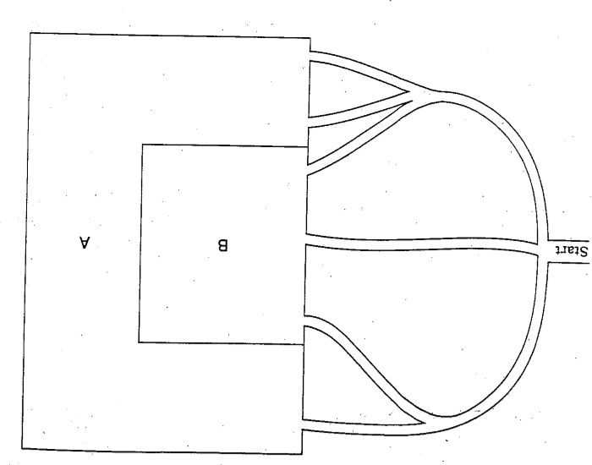

Second Cave

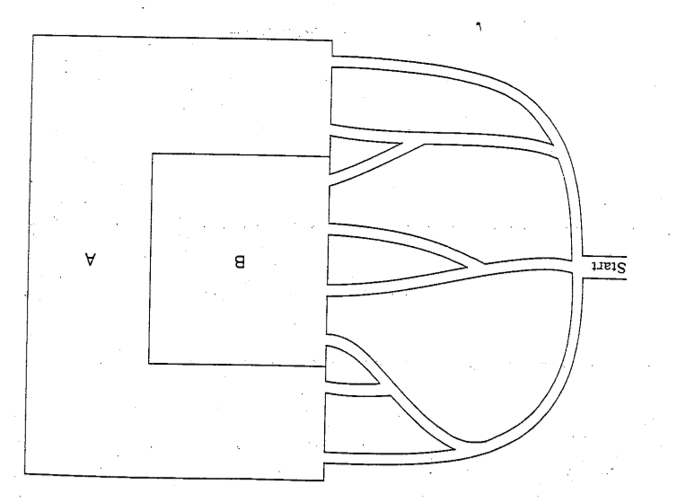

**Day 1 Kalvin’s Marshmallows**

9.4.3.2 Calculate experimental probabilities by performing simulations or experiments involving a probability model and using relative frequencies of outcomes.

9.4.3.8 Apply probability concepts to real-world situations to make informed decisions.

**Objective:** SWBAT perform a simulation of a situation to help them create a probability model and compare the experimental and theoretical probabilities of a given situation.

**Materials:** large and small marshmallows (enough for each group to have 1 large and 4 small), large cups for students to use to roll the marshmallows.

**Launch:** The teacher will start with a story about Kalvin “Kalvin wants to eat Coco blast but his mom doesn't want him to because it's to sugary. So, Kalvin decides to flip a penny. Every time he gets a head he eats coco blast, and every time he gets tails he doesn't. Later on he found out it did not help b/c it was a 50% chance for both.” (students would have already done an experiment with flipping a penny and would have that information. If not you could have them to that as well and extend this lesson.) “So he tried with a marshmallow, tails=land on base heads=land on side. He tossed it 2x and it landed on both of each once. He says the marshmallow it isn't any better than the penny - it lands on an end 50% of the time. How would you convince Kalvin that the marshmallow is better for him to use than the penny?”

**Explore:** Students would than in groups start collecting data by running the experiment (15-30 times should be good per group, depending on the size of your class.) Students will compile their data as a class in a spread sheet can be done as a complete class or student by student. Once students have gathered all the data and discussed the large marshmallows pose the question of rolling a small marshmallow to see if that make the outcome more in Kalvin’s favor.

**Share:** Students will share out their groups results and from their experiments which method do they think Kalvin should choose and why. Q: How did you come to that conclusion? What is the probability that Kalvin will eat the sugary cereal each day from your/class experiential data?

**Summarize:** The teacher will summarize the student’s responses and talk about how the question of why the students think that probability changed and even though Kalvin has a better chance of eating the sugar cereal he will still have to eat the other one for some of the days from the classes experimental data. The teacher will also summarize how what they found was an experimental probability and the cave activity gave them a theoretical probability and how the two are different.

**Day 2 Hey, That’s Not Fair**

9.4.3.1 Select and apply counting procedures, such as the multiplication and addition principles and tree diagrams, to determine the size of a sample space (the number of possible outcomes) and to calculate probabilities.

9.4.3.4 Use random numbers generated by a calculator or a spreadsheet, or taken from a table, to perform probability simulations and to introduce fairness into decision making.

**Objective:** SWBAT determine fair and unfair games by collecting and organizing data to predict possible outcomes.

**Materials:** 3 dice for each group (you could have them roll one dice 3 times if you do not have enough for 3 dice for each group), student hand out sheet (one per group)

**Launch:** Ask each group to choose a player A and player B before giving directions. For Game 1 they will roll the 3 dice and if the sum is odd player A gets a point if it is even player B gets a point. Game 2 players will roll 3 dice and multiply them together. If the product is odd player A scores a point it is it even Player B scores a point.

**Explore:** Students will play the game in pairs and record their results in the table provided by the teacher. (student activity sheet below) One students have finished their 20 plays for game one ask them is this game fair and why or why not? Have the students analyze the game to determine fairness by listing all the possible outcomes (there is a page attached for them to create tree diagrams with or you could let them come up with that on their own.) They can use the list they create to find the fraction of outcomes that are odd and even. Student can than repeat this process with game 2 (this may be a two-day activity depending on how long it takes your students to play the game.) Students will look for similarities and differences between the games when deciding if they are fair or not fair.

**Share:** Students will share out their thoughts with the whole class you could use smaller groups for groups of 2 to share their outcomes with before moving to whole class. Student swill if each game is fair and why or why not. How they determined if the game was fair or unfair. Why did they choose to include what they did in their chart or model for their explanation? Q: how many possible ways are there to get an even/odd answer in each game? Q: Are there any advantages in either of the games? Why or why not?

**Summarize:** The teacher will summarize what does fair mean and how the two games relate to each out. What makes the game fair or unfair? How we can find out if a game is fair or unfair by using theoretical probability or by running an experiment and using experimental probability.

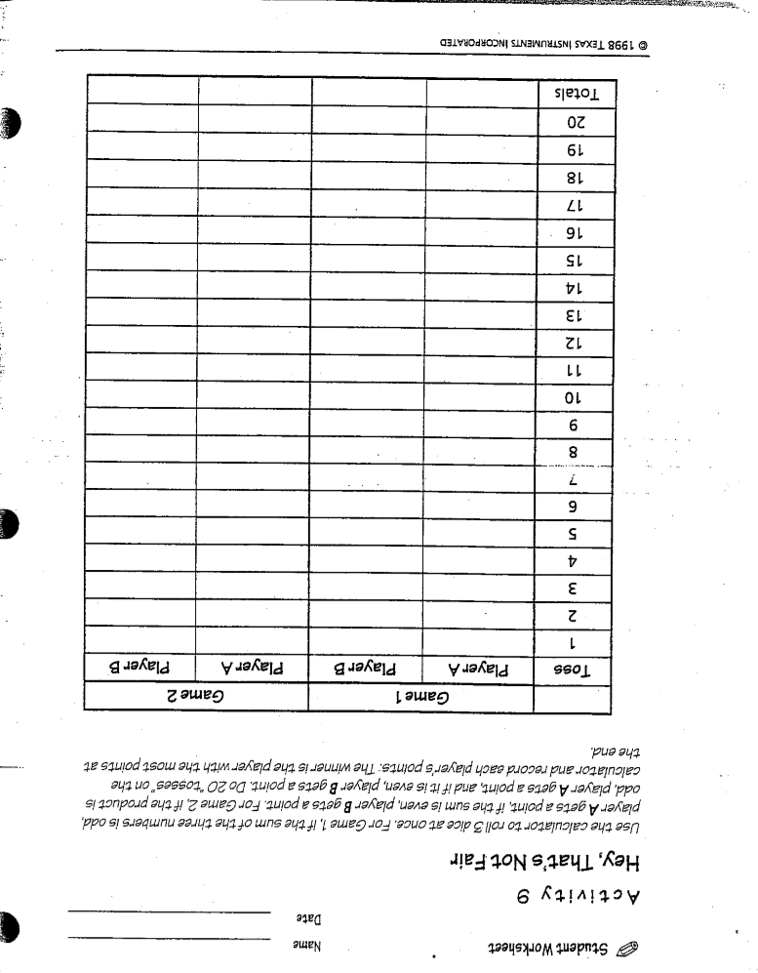

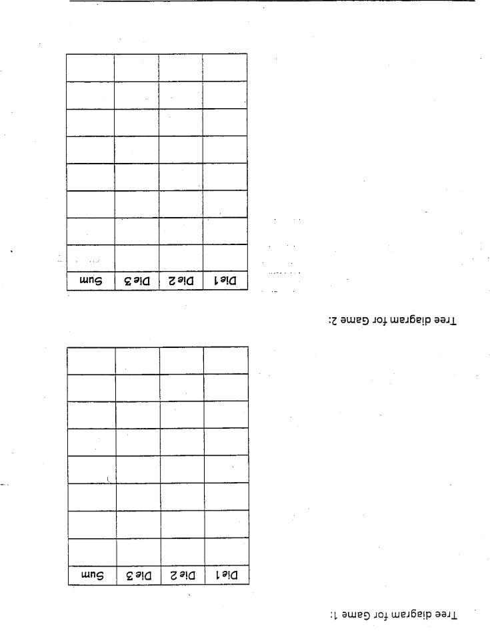

**Day 3 More than 2 events**

9.4.3.1 Select and apply counting procedures, such as the multiplication and addition principles and tree diagrams, to determine the size of a sample space (the number of possible outcomes) and to calculate probabilities.

9.4.3.4 Use random numbers generated by a calculator or a spreadsheet, or taken from a table, to perform probability simulations and to introduce fairness into decision making.

Note students will have already worked with single event probability before this lesson.

**Objective:** SWBAT find the sample space of a compound event and create an experiment to come up with and compare an experimental and theoretical compound event probability. Students will look at the probability when two events both occur.

**Materials:** Two pennies and a nickel or dime for each group of students.

**Launch:** Teacher will start with giving the following story. 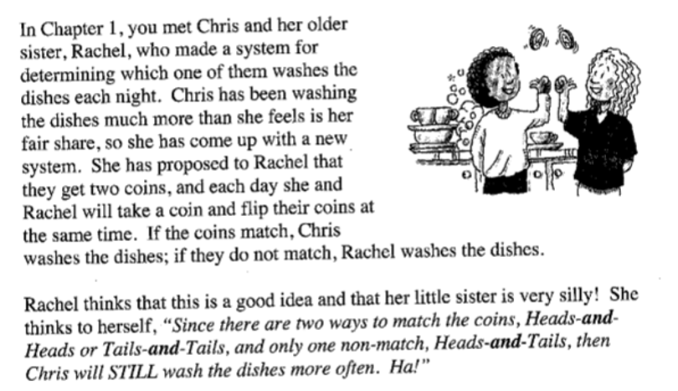

The teacher will ask the students if they agree with Rachel and to set up an experiment to help show if they are correct or not.

**Explore:** In small groups, the students will design and complete their experiments. (you can help guide the experiments or if they have had practice creating and running experiments let them do that entire process.) After collecting their data groups will share that with the teacher who will make a collective class data sheet on excel. The following are questions for the students to look at after they have completed their experiment.

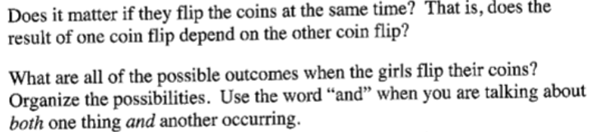

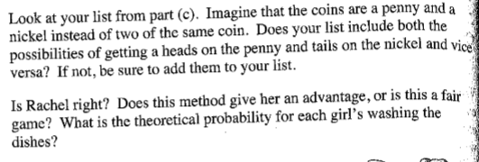

**Share:** Student groups will share out their responses to the questions they looked at during their exploration. Does order matter? Is Rachel right? Is there an advantage if so who has that advantage? Is this arrangement fair, why or why not? What are the different possible outcomes and how do you know you have all the outcomes?

**Summarize:** The teacher will summarize and pull back tot eh previous lesson on if the new arrangement is fair or unfair and why by looking at the models the students have made to show the outcomes. The teacher will make sure the students look at the comparison from the experimental to the theoretical and ask why are they not the same. Teacher will talk about how this compound event is different from other probabilities the class has explored in the past.

**Day 4 & 5 Abby’s Kennel**

9.4.2.3 Design simple experiments and explain the impact of sampling methods, bias and the phrasing of questions asked during data collection.

9.4.3.6 Describe the concepts of intersections, unions and complements using Venn diagrams. Understand the relationships between these concepts and the words AND, OR, NOT, as used in computerized searches and spreadsheets.

9.4.3.7 Understand and use simple probability formulas involving intersections, unions and complements of events.

**Objective:** SWBAT collect data from an experiment and organize it to be able to answer question about the data.

**Materials:** Abby’s Kennel tables and story attached below, red and blue colored paper, paper bags (enough for each group to have one set of 50 red and 20 blue papers).

**Launch:** DAY 4 Teacher will read through Abby Kennel story attached below and ask the students to guess what they think the outcome will be. Explain that each group will be getting 3 bags and that they will be collecting data from each bag and filling in the tables provided.

DAY 5 The teacher will pose the question of how one would show the data collected in a venn diagram and for the students to look at the frequencies found from the experimental data collected the previous day.

**Explore:** DAY 4 Students will run the experiment and fill in the attached table. Students will than take that data and place it into tables that help to make it easy to read and so it can be used to make conjectures between the 3 bags that where used to complete the experiment.

DAY 5 Students will work through the attached questions about venn diagrams and union as groups to look at the collected data through a critical eye. Work on answering the following questions.

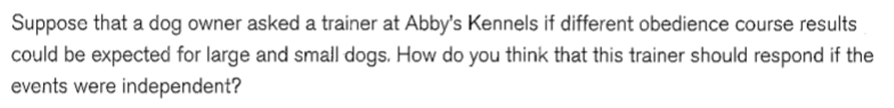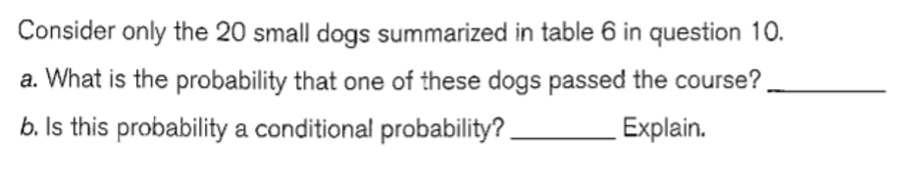

**Share:** Student groups will share their data and results with the class. Students will share there answers to the questions above and why they feel they have chosen the correct venn diagram to represent the data they collected.

**Summarize:** Teacher will review how the experimental probability was used and the organization of the data in tables and venn diagrams. Teacher will also look at points from the data that allowed for students to answer specific questions. How the organization of that data allowed for those questions to be answered.

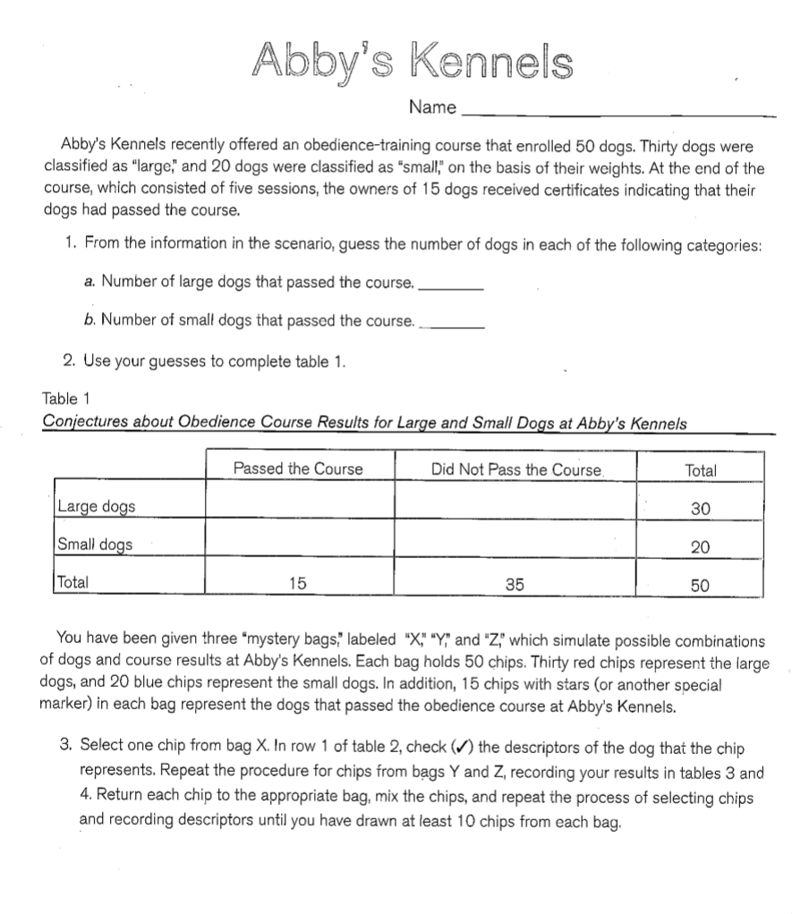

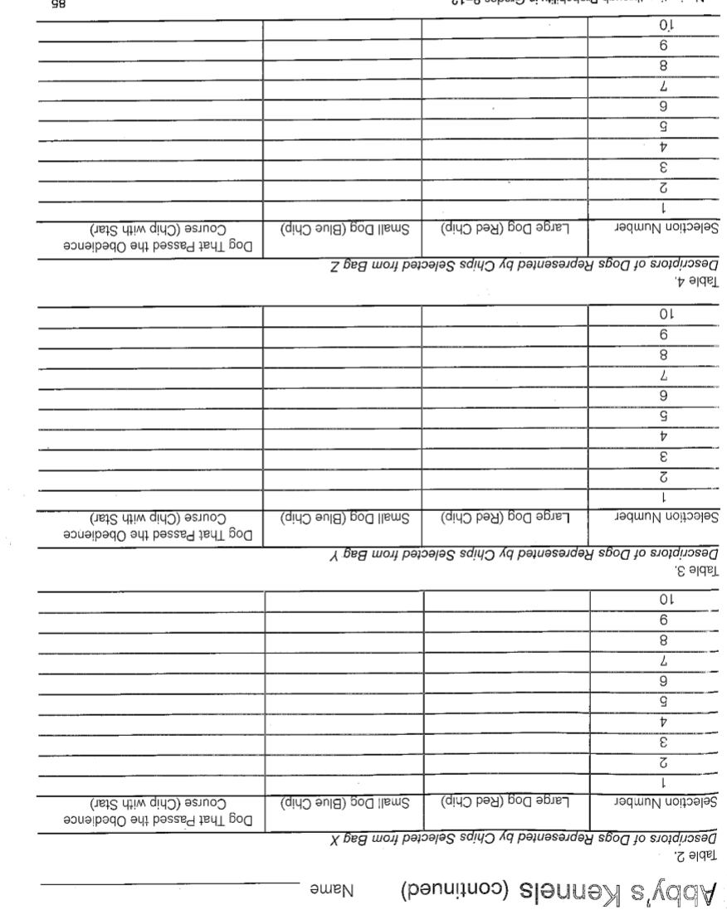

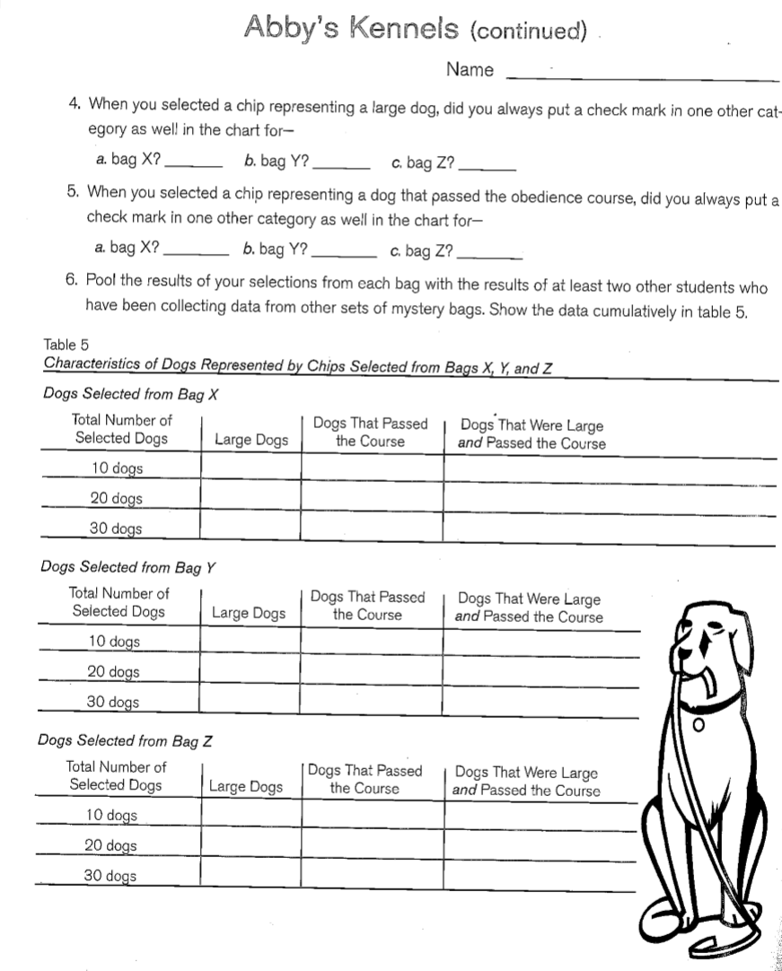

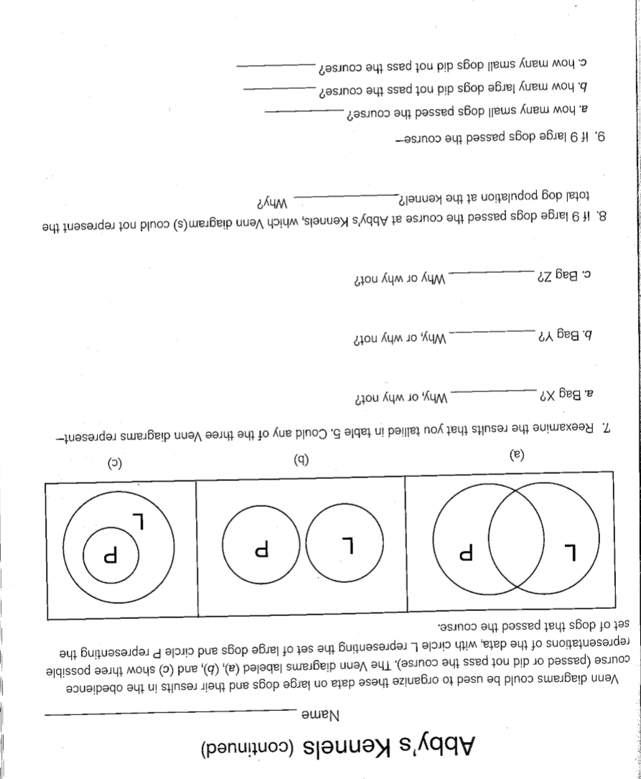

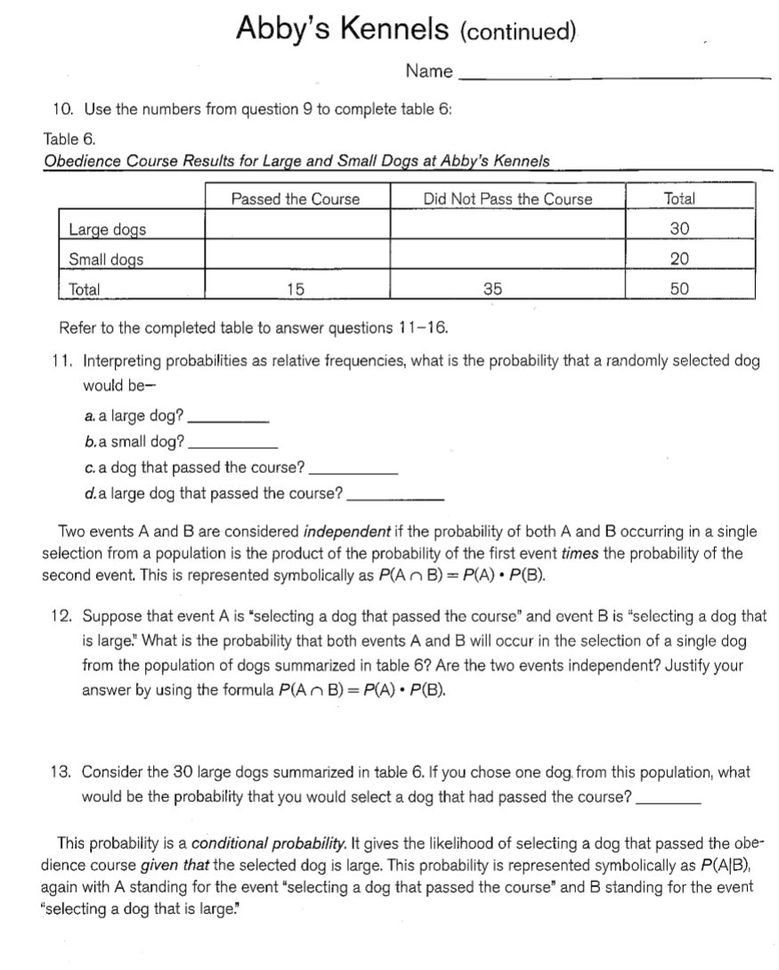

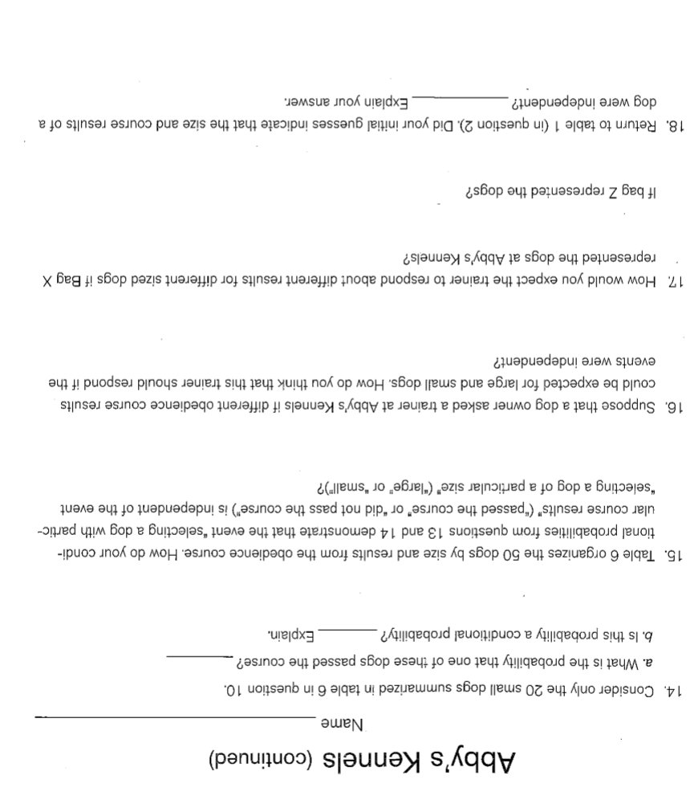

**Day 1 Lottery**

9.4.3.1 Select and apply counting procedures, such as the multiplication and addition principles and tree diagrams, to determine the size of a sample space (the number of possible outcomes) and to calculate probabilities.

**Objective:** SWBAT take an unfair game and make changes to create a fair game and caculate the probability of winning both games.

**Launch:** The teacher will tell the class about the state of Michigan’s million-dollar lottery. “All winners of a $50 “Ace Three” game were assigned a number and invited to the million dollar drawing. This year there were 11,651 $50 winners of “Ace Three”. To determine the millionaire, the lottery bureau drew a single digit from each of five pools corresponding to the place value positions until a five-digit number corresponding to one of the numbers 00001 to 11,651 was completed. If a number was draw that did not fall in the range needed to complete the five digit number, it was thrown back and another number was drawn.” Than the question will be given, did each contestant have the same chance of winning the million dollars?

**Explore:** Students will work in groups to first figure out what is the probability for different people to win and is this a fair game. Than they will look at ways to make the game more fair. How could they draw a person in a way that gave everyone a fair chance? What is the issue with the game as it is? What number or range of numbers would you want to be in to have the best probability of winning.

**Share:** Student groups will share out first if they think the lottery is fair and why they came to that conclusion. Than students will give their example of how they think the game can be fixed and the probability of winning the new game. Is there new game fair? Does the number of people matter that are entered into the lottery?

**Summarize:** The teacher will review fair and unfair terms and how the changes made to the game make the odds more even for those participating. Q: Are the new games create fair? Teacher will talk about how experimental probability was used for the most part to solve this problem and not experimental because of the size of the sample space.

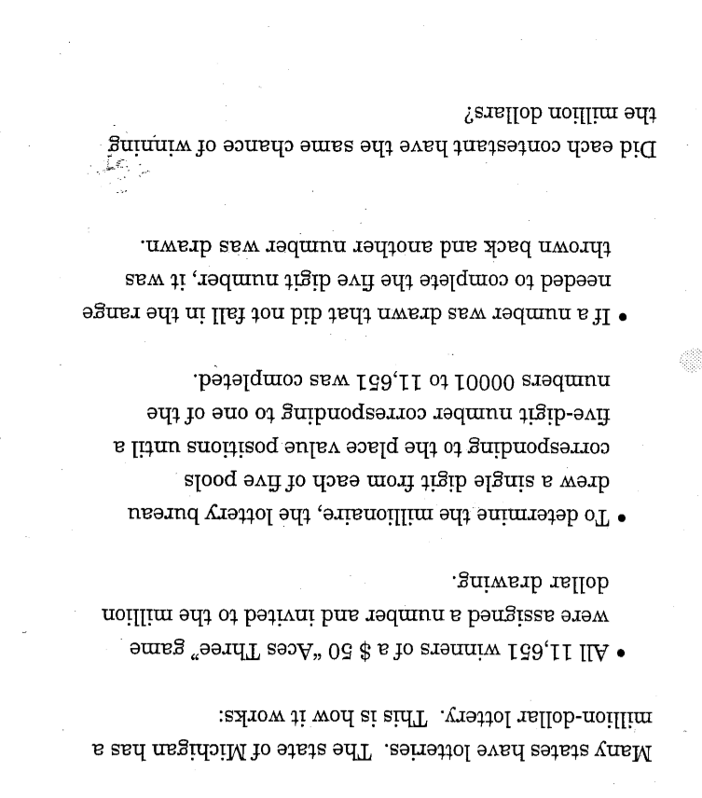

**Day 2 & 3 Clever Counting**

9.4.3.1 Select and apply counting procedures, such as the multiplication and addition principles and tree diagrams, to determine the size of a sample space (the number of possible outcomes) and to calculate probabilities.

**Objective:** SWBAT use counting techniques to find large numbers of lock combinations and path ways.

**Materials:** Clever counting story attached below (optional locks)

**Launch:** Day 2the teacher will read the story The Case of the Looted Locker to the class and pose the question. Based on the information given whom would you suspect? What questions would you like to ask Willie, the manager, the night guard, the guard’s friend, or the detective? Could the night guard, his friend or the person who left in the van, open Willie’s locker without the combination?

After the class has made a lost of questions the teacher will read the second part of the story. “The detective though that the warehouse manager and Willie himself were really prime suspects. But before making any arrests she wanted to know if the night guard or his friend could really open the lock by trying all the possible combinations. It is a dial lock with a 3 digit number combination 0-39.

Day 3 Teacher will give more information from the detective. “The detective decided that she needed to look at other suspects. She investigated how a burglar could have hidden from the security guard when he made his patrol. Diagram given in attached document of one possible path.” How many different path ways are possible?

**Explore:** Day 2 Students will work in groups to come up with a list of questions and suspects to ask those involved in the case. I would do this piece as a think pair share to be able to gather information both from individuals and the class as a whole. Is it possible for the guard or his friend to try all possible combinations? What would they be and how long would that take?

Day 3 Students will work in small groups to come up with a way to count all the possible path ways. What are we counting as a path? How many round trip paths are there? What is the probability that the thieves escape route will be the same as the guard’s patrol?

**Share:** Day 2 students will share out and compare their numbers for the time it will take to try all combinations. Would they have to try every single combination? How did you arrive at that number?

Day 3 student groups will share their number of paths and how they came up with that number. If student groups differ lead a discussion about the differences and why that occurred. Is this an easy or fast sample space to count? Is there a way to model this space to help us count? How would your answer change in this proble is there were 15 aisles from A to B and 12 aisles from B to C?

**Summarize:**  Day 2 short summary from the teacher about the lock combinations and why they might not need to try every combination.

Day 3 The teacher will summarize the different counting strategies used. This would lead in to combinations and permutations, but not needed in this activity. How does this help us solve the case of the looted locker?

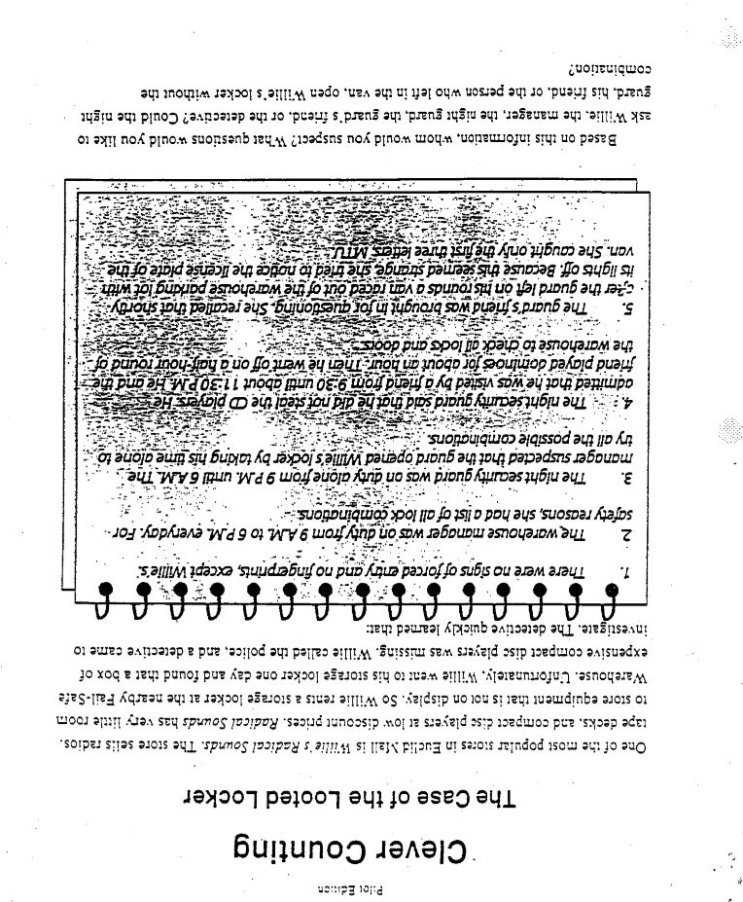

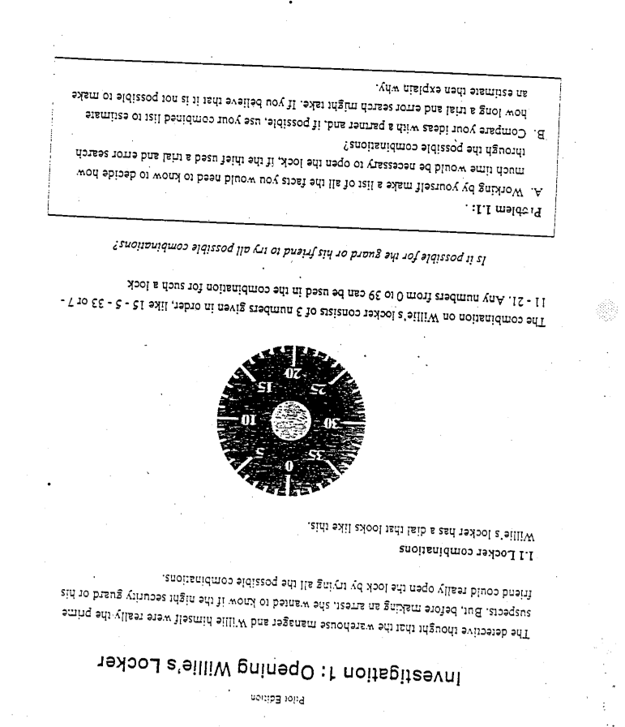

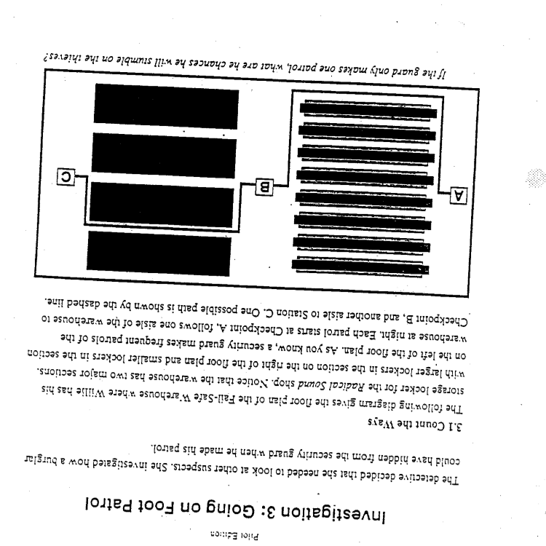

**Day 1: Rank by Preference**

**Introduction:** Prior to this unit, students have learned how to calculate basic probabilities, so the idea of probability is not new to them.

**Launch:**

1. Students will take a pre-test on the material. This unit focuses on one main idea, expected value, so it is a short pre-test that should only take about 10 – 15 minutes at the start of class. The pre-test is included after the lessons for this unit.

**Explore:**

1. Present the following question to the class:
   1. Miley Cyrus, Beyoncé, and Nicki Minaj are trying to figure out which one of them is the most popular. They decide to ask 20 random people to rank them from favorite (1) to least favorite (3). The results are as follows:

|  |  |  |  |
| --- | --- | --- | --- |
|  | **1 (favorite)** | **2** | **3 (least favorite)** |
| **Miley Cyrus** | 5 | 7 | 8 |
| **Beyoncé** | 9 | 2 | 9 |
| **Nicki Minaj** | 4 | 11 | 5 |

* 1. Who is the most popular?

1. Students should work with their groups to come up with a solution. Once they have a solution, students must show their work on the board with some sort of work or explanation.

**Share:**

1. Students will share their method to the class. After all of the groups have shared their work, a mathematical conclusion should be made about who is the most popular.
2. Once students have a method for how they would solve this problem. Present them with the following problem:
   1. Four designers must choose between four colors for their next project. They all could not decide on just one color, so they decided to rank each color from their favorite to least favorite.
      1. Designer 1: blue, yellow, green, purple
      2. Designer 2: purple, blue, green, yellow
      3. Designer 3: yellow, purple, green, blue
      4. Designer 4: blue, purple, yellow, green
   2. Which color is ranked #1?
3. Have students share suggestions on how this problem will change from the first problem since you are comparing more items.
4. Then have students come up with an answer and discuss everyone’s results as a class.

**Summary:**

1. By the end of the lesson, students should realize they are assigning points to each item being ranked by summing up the number of times they were ranked 1, 2, 3, etc. This will lead into the lesson the following day on expected value.

**Day 2: Expected Value Introduction – Candy Math**

**MN State Standards:**

* 9.4.3.2 Calculate experimental probabilities by performing simulations or experiments involving a probability model and using relative frequencies of outcomes

**Materials:**

* 1 small pack of M & Ms per person
* Candy Math worksheet
* Candy Math Experiment worksheet

**Launch:**

1. Hand out the Candy Math worksheet to each student along with a packet of M & M’s. Tell students they will be performing an experiment with them so they should NOT eat them until instructed!
2. Students should complete the Candy Math worksheet. This will help students review probability, but every student will have different answers because they will have a different amount of M & M’s in their bag.

**Explore:**

1. Once students have the probabilities of getting each color written down, introduce the Candy Math Experiment to them.
2. They will be conducting their own experiment by drawing candy from their own bag and recording their color. Each color is assigned a specific point value, which is given on the Candy Math Experiment worksheet.
3. Before performing their experiment, students are going to decide whether or not they think this is a fair experiment based off of their candy.

**Share:**

1. Students will discuss with their group why they think their specific experiment is going to be fair or not fair.
2. Once the groups have had a chance to discuss, have different students explain their answers to the class.
3. Students should realize that the fairness of the game all depends on how many of each color they have.

**Summary:**

1. To finish class, students will be running their experiment for 50 trials. They will record how much of each color they get and then record how many points they end up with.
   1. They will calculate these points using a similar method that was learned the previous day where they have to multiply each outcome by its specific point value. For example, since each red candy is worth three points, they will multiply the number of red candies they got by 3. They will do this for each color and then find the sum.
2. Finally, after running this experiment they will make a final conclusion on whether or not they think their experiment was fair.
3. Have students share their final conclusion with the members in their group.
4. Let students know they can eat their candy but we will be continuing on with this activity the following day.

**Candy Math**

**Total Number of Candies: _________**

|  |  |  |
| --- | --- | --- |
| * **Blue: ______** * **Green:______** | * **Yellow: ______** * **Red: ______** | * **Orange: ______** * **Brown: ______** |

**Practice Problems:** What is the probability of grabbing….

1. A blue, green, yellow, red, orange, or brown candy? __________________
2. A pink candy? ________

|  |  |
| --- | --- |
| 1. A blue candy? ________ | 1. A green candy? ________ |
| 1. A yellow candy? ________ | 1. A red candy? ________ |
| 1. An orange candy? ________ | 1. A brown candy? ________ |

1. Find the sum of the probabilities from problems 3 – 8: __________________________

**Candy Math**

**Total Number of Candies: _________**

|  |  |  |
| --- | --- | --- |
| * **Blue: ______** * **Green:______** | * **Yellow: ______** * **Red: ______** | * **Orange: ______** * **Brown: ______** |

**Practice Problems:** What is the probability of grabbing….

1. A blue, green, yellow, red, orange, or brown candy? __________________
2. A pink candy? ________

|  |  |
| --- | --- |
| 1. A blue candy? ________ | 1. A green candy? ________ |
| 1. A yellow candy? ________ | 1. A red candy? ________ |
| 1. An orange candy? ________ | 1. A brown candy? ________ |

1. Find the sum of the probabilities from problems 3 – 8: __________________________

**Candy Math Experiment:**

You are going to be performing an experiment with your candy. Put your candy back in your bag. You will be drawing one candy, recording the color, and then putting it back.

Each piece of candy is assigned a specific point value. So if you draw that color, you get that number of points. The point values are as follows:

**Red: 3 points Orange: 2 points Yellow: 1 points**

**Green: 0 points Blue: -1 point Brown: -2 points**

1. Before you run your experiment, do you think this is a fair game according to the colors in your bag? Why or why not?
2. Run 50 trials of this game and record your answers below:

|  |  |  |  |  |  |
| --- | --- | --- | --- | --- | --- |
| **Red** | **Orange** | **Yellow** | **Green** | **Blue** | **Brown** |
|  |  |  |  |  |  |

**Total:** Red:_______ Orange: ______ Yellow:_______ Green:_______ Blue:_______ Brown:_______

1. How many points did you end up with?_________________
2. Now that you have completed 50 trials of your experiment, do you think this experiment is fair? Why or why not?

**Day 3: Expected Value**

**MN State Standards and Common Core State Standards:**

* 9.4.3.8 Apply probability concepts to real-world situations to make informed decisions
* Weigh the possible outcomes of a decision by assigning probabilities to payoff values and finding expected values

**Materials:**

* Students will need both of their Candy Math worksheets from the day before

**Launch:**

1. Give students a brief overview of the previous day’s activities. They should have the data that they took yesterday running their experiment with candy.
2. Have students spend a couple minutes reviewing with their group what they did in the experiment and why they thought the experiment was fair or not.
   1. Make sure to have them discuss why some students may think the experiment is fair and others may not even though they are all doing the same thing.
3. Ask the students to come up with some mathematical way to prove their theory. If they thought the game was unfair, they should show you why it’s unfair. If they thought it was fair, they should show you math to prove it is fair.

**Explore:**

1. Let students work in their groups to answer this question. Each person will have a different answer because they have different data sets, but they can work together on forming a mathematical strategy.
2. If students are struggling, offer them two suggestions:
   1. They can try and think of a method using their data to see how many points they won or lost per color.
   2. They can start thinking about probability and using a similar strategy used on Day 1 of the unit.

**Share:**

1. Once students have time to come up with an answer in their groups, have students share their ideas.
   1. First, ask if any students used their specific data to figure out how much they won or lost per color by taking how much they won or lost and dividing it by the number of total trials.
   2. Once this has been explained, then have students (if any) who used probability explain their thinking.
   3. If students are struggling getting to the probability part, use questions to guide them in the right direction until they figure it out.

**Summary:**

1. By the end of the class discussion, students should understand that expected value is:
   1. E(x) = sum of (each event x the probability of each event)
   2. So, in our case, each event would be the possibility of getting 3, 2, 1, 0, -1, or -2 points, and the probability would be their specific probabilities of getting each color.
   3. Because everyone had different numbers of candy, some students may have a fair game and some may not.
2. Have students calculate the expected value for their experiment using the new formula. To summarize what they’ve done, they should discuss with an elbow partner what exactly expected value means.
   1. For example, if you got E(x) = -5.4, what does this mean? How do you determine if this is fair or not?

**Day 4: Who is the Winner?**

**MN State Standards:**

* 9.4.3.8 Apply probability concepts to real-world situations to make informed decisions
* Weigh the possible outcomes of a decision by assigning probabilities to payoff values and finding expected values

**Materials:**

* Expected Value Examples worksheet

**Launch:**

1. As a warm up, have students work with a partner to answer this expected value question:
   1. A fair six-sided die is tossed. You win $2 if the result is a “1”, you win $1 if the result is a “6”, but otherwise you lose $1.
   2. Areas of focus should be that students can pick out the possible events or outcomes (in this case +$2, +1, and -$1 and that they remember to multiply each of these by the appropriate probability and add them together.
   3. Discuss how this is different than the previous day because now we are working with theoretical probabilities instead of experimental.
2. Review the answer with the class and go over any questions before moving on.

**Explore:**

1. Hand out the Expected Value Examples worksheet.
2. On the worksheet, there are problems that are fair and not fair. For each question, students must determine:
   1. Is the game fair or not
   2. Would they want to play this game
   3. What does the expected value mean in that particular problem
3. Once students complete the worksheet, they are going to pick one game on the worksheet that they would want to play the most.

**Share:**

1. Students will write which game they would prefer to play on the board, and then the class will discuss the different answers.
2. Key points of discussion should be why a certain game may want to be played and why another one would not want to be played. This will also lead into a discussion on what the expected value means in a particular problem (how much you can expect to win or lose if you play the game long enough).
   1. Students should also make note that a game is only fair if the expected value is 0. If it is positive, you may want to play the game because it is in your favor, but it is not fair because you are more likely to win money than lose money. A fair game would be that you come out even [E(x) = 0]. It may be worth mentioning to students that the candy math experiment that they did the previous two days is only fair if they ended up with a final score of 0.
3. Question 4 on the worksheet is slightly different because once they have their expected value, they need to subtract 1 because they had to pay a dollar to play the game. Make sure students notice this difference and know how it changes their expected value.

**Summary:**

1. Have students work in groups of four to come up with their own expected value game. Since they are the makers of the game, they want the player to lose money overall. They will be trying to convince classmates to play their game the following day, so they want the game to seem favorable to the player in the game rules. More directions will be given the next day.

**Expected Value Examples**

1. In game 1, you toss two quarters in the air. If the coins come up the same (both heads or both tails), you win both quarters. If the coins come up different (one head and one tail), then you lose both quarters. Find your expected winnings.

|  |  |  |
| --- | --- | --- |
| **Value of**  **Winning** |  |  |
| **Probability** |  |  |

E(x) = ___________________

1. In game 2, you are drawing one card from a standard 52-card deck. If you draw a face card, you win $5. If you do not draw a face card, you lose $1.50. What are your expected winnings?

|  |  |  |
| --- | --- | --- |
| **Value of**  **Winning** |  |  |
| **Probability** |  |  |

E(x) = __________________

1. In game 3, you roll a single die. If it’s a 2 or 5, you win $1. If it is a 1, 4, or 6, you lose $0.75. If it is a 3, you win $0.25. What are your expected winnings?

|  |  |  |  |
| --- | --- | --- | --- |
| **Value of**  **Winning** |  |  |  |
| **Probability** |  |  |  |

Ex) ___________________

1. In game 4, in order to play you have to pay $1. Then you roll two dice. If you get doubles, you win $4. If you do not roll doubles, you do not get any money back. Find your expected winnings.

|  |  |  |
| --- | --- | --- |
| **Value of**  **Winning** |  |  |
| **Probability** |  |  |

E(x) = ___________________

E(x)

**Day 5: Expected Value Carnival**

**MN State Standards and Common Core State Standards:**

* 9.4.3.2 Calculate experimental probabilities by performing simulations or experiments involving a probability model and using relative frequencies of outcomes
* 9.4.4.3 Understand that the Law of Large Numbers expresses a relationship between the probabilities in a probability model and the experimental probabilities found by performing simulations or experiments involving the model
* 9.4.3.8 Apply probability concepts to real-world situations to make informed decisions
* Weigh the possible outcomes of a decision by assigning probabilities to payoff values and finding expected values

**Launch:**

1. Have students get in the groups they were in the day before. They should come up with an expected value problem (or finish what they started the day before). Their goal is to come up with a game that has a negative expected value because then the player loses and they win. However, it should not be obvious that the expected value is negative.
   1. Groups should calculate their expected value to make sure they are satisfied with the outcome of their game, but they should keep it a secret from others.
   2. These games can be anything from drawing a card from a deck, rolling dice, flipping coins, spinning a spinner, or anything else they can think of with calculable probability.

**Explore:**

1. We are going to be having a classroom carnival. Each group will present their game to the rest of the class. They should explain if it costs any money to play (it should in theory cost some amount of tickets to play a carnival game), and how much they win or lose if they play.
2. Once each group has had a chance to present, students will rank the games by which ones they think are most favorable to least favorable. They should do this without doing any sort of calculations. It should just be a gut instinct from listening to the presenters.
3. Next, students will take ten minutes walking around and playing each other’s games. One person from each group must stay at their station to run the game and keep track of the amount paid to play and the amount won.
   1. This recorder should switch every couple of minutes.
4. Finally, once the time for playing is complete, each group must calculate the total amount of money or tickets paid into their game and how much was paid out. Then, they should calculate the experimental expected value (money made or lost divided by total games).

**Share:**

1. Each group will write their results on the board. Next to their results they will also write their expected value for their game that they calculated at the beginning of class as well as their experimental expected value.
2. Students should compare these two values with how they ranked the games at the beginning of class. They should write down any changes they would make to their ranking based off of the expected value.

**Summary:**

1. The overall idea of expected value is that you are looking at what you can expect to gain after many trials. Because we only played these games for 10 minutes, some games may have ended up losing money when they should have won. Any time we are playing a game of chance, the more trials you complete, the closer your results will be to the theoretical probabilities and expected values.

**Conclusion:** Students will take a post-test. This post-test is the same as the pre-test given at the beginning of the unit.

**Expected Value Pre/Post Test**

1. Find the following probabilities:
   1. Flipping two coins and getting both heads
   2. Rolling a dice and getting an odd number
   3. Rolling two dice and getting doubles
   4. Picking an Ace from a deck of cards
2. You are playing a game where you spin the spinner below. If you land on red or yellow, you win $1. If it lands on purple, you win $2. If it lands on orange, you lose $3. Find the expected value of this game.

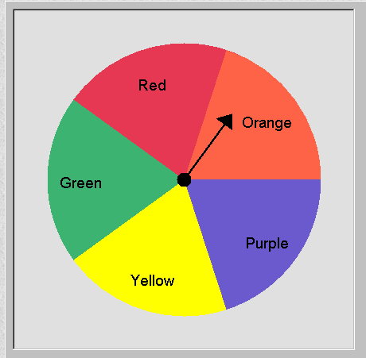

a. What is the expected value?

E(x) = ___________________

|  |  |  |  |  |
| --- | --- | --- | --- | --- |
| **Value of Winning** |  |  |  |  |
| **Probability** |  |  |  |  |

* 1. Is this a fair game? YES or NO
  2. Why or why not?
  3. What does the expected value tell us in this situation?

Pre/Post Test Models of a Sample Space and experimental/theoretical proability

1. a. Find the theretical probability of the following problems.

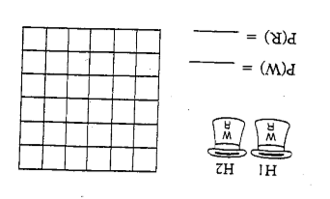

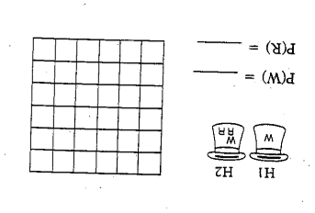

* 1. Which one of these hats are fair and which one is unfair and why?

1. You are flipping 3 fair coins
   1. Create a model that shows the outcomes from flipping the 3 fair coins.
   2. What is the probability of getting all heads, two heads and 1 tail, and all the same?

P(HHH) =

P(2H & 1T)=

P(HHH or TTT)=

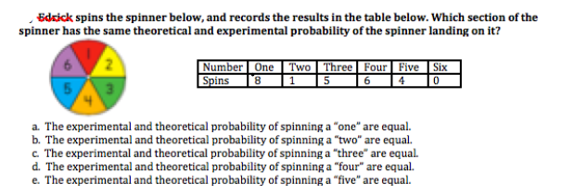

1. Define the following in your own words.

Theoretical Probability-

Experimental Probability-

Fair game-